!S6 Bluejacking UsrMan

Sydney Hardwick
IIT School of Applied Technology
shardwic@hawk.iit.edu

Pi Lai Ngai
IIT School of Applied Technology
pngai@hawk.iit.edu

Chaz Granholm
IIT School of Applied Technology
cgranhol@hawk.iit.edu

USRMAN
This User Manual is intended to help others emulate and utilize the Ubertooth Project quickly and effectively. The source code is constantly updated by the fine folks of the Uberooth development community. The following instructions are respective to the most up-to-date versions of the code at the time of publication. Through crowdfunding efforts and open collabortion, the Ubertooth Project has developed affordable and eay to use tools to further development for the security and funtionality of Bluetooth.

SETTING UP ENVIRONMENT
We will be running Kali Linux through VirtualBox, porting USB access through to Kali.
Create new Kali Machine, Enable USB, Create Filters
Boot Kali + Complete Installation
Update Repositories and Distro
Uninstall Old Python USB Libraries
Install PySide and Dependencies
Update PyUSB
Install LibBTBB
Download Ubertooth

Downloads
Begin by downloading up-to-date VirtualBox and Guest Extensions Pack from virtualbox.org/wiki/Downloads and Kali Disk Image (.iso) from kali.org/downloads.

Virtual Box

Install Virtual Box by … version 4.3.20

Virtual Box Guest Extensions
Install Virtual Box Guest Extensions by version 4.3.20
    - Create a Virtual Machine
Create a new Linux, Debian machine which will help us install the Kali .iso. Allocate an appropriate amount of memory that your system can handle, with two gigabytes as an adequate reference. When prompted, choose “Do not create a virtual hard drive,” as the .iso will perform this task. Highlight the new machine that should appear in Virtual Box’s Machine Manager Window and select “Settings”
Under “Devices” Enable USB 2.0 and create a USB Filter.
(Optional) Under “Storage” guest additions

Enable USB to Virtual Machine

Under “Devices” Enable USB 2.0 and create a USB Filter to include the Ubertooth One device. A blank filter currently catches every USB attached by default in Virtual Box.

Kali Linux

Boot the Kali machine and begin installation, using the appropriate settings for Language, Country, and Keymap.
When prompted to partition disks, select “Guided – use entire disk,” and “All files in one partition,” and “Finish partitioning and write changes to disk” barring any errors.
If connected to the Internet, Network Mirrors can be used for configuring the Packet Manager. The following field for HTTP Proxy should be left blank unless otherwise necessary.
The Grub boot loader can be installed to the hard disk.
Installation should now be complete, but if you received an error regarding PAE, see the Kali machine’s Processor Settings in the Virtual Box Machine Manager.

Terminal
  - Update Repositories and Distro
sudo apt-get dist-upgrade && install
  - Uninstall Old Python USB Libraries
sudo apt-get pyusb//???
  - Install PySide and Dependencies
sudo apt-get pyside ...//???
Remember, if a process ever freezes in your terminal, you can often close it with ‘ctrl+z’ //displayed as ^Z in the terminal.

Ubertooth One
Never operate the Ubertooth One without an antenna
Do not attempt to use Ubertooth One without its bootloader installed.
The Ubertooth One device can be reset by simply unpluging and replacing the device back into the usb port.

BUILD GUIDE
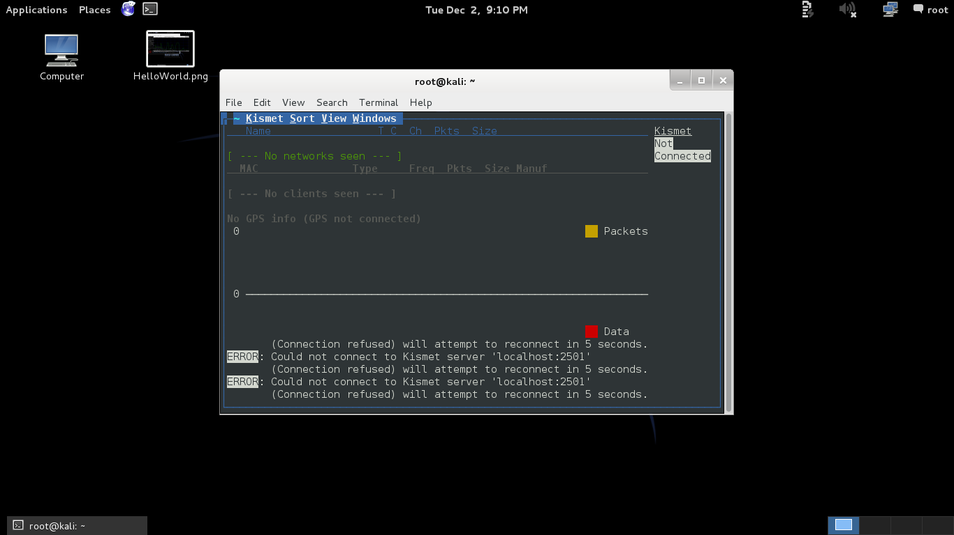
This build guide lists software dependencies, locations and instructions on how to install and execute them gathered from various sources
  - PyUsb //current version: 1.0.0b2
sudo python setup.py install //current version: 1.0.0b2
  - LibBTBB //current version: 2014-02-R2
../build/
cmake ..
make
sudo make install
  - Ubertooth //current version: 2014-04-R1
../host/build/
cmake ..
make
sudo make install
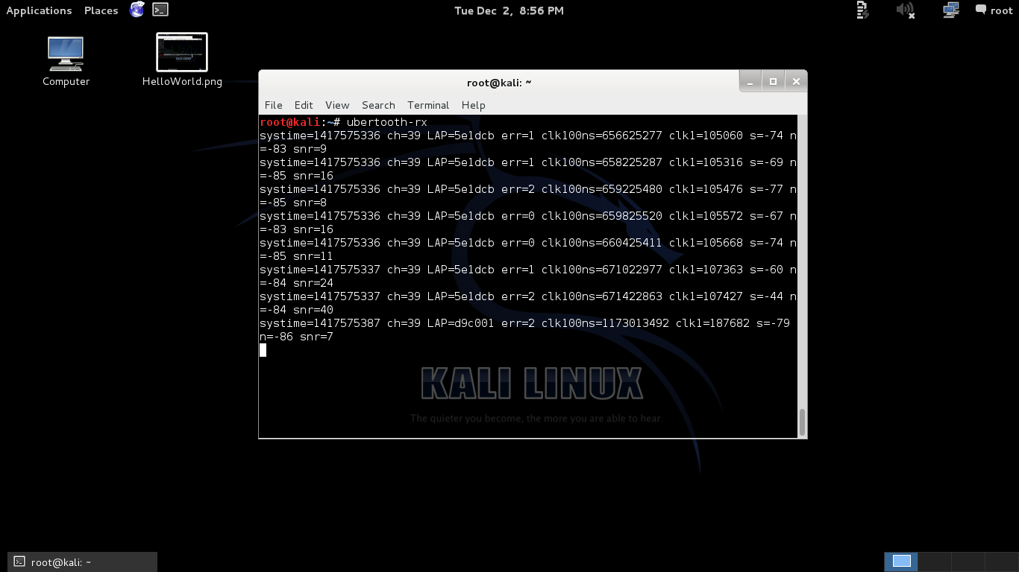
sudo ldconfig //This is the command I missed the first time round
  - ubertooth-follow tool //this task may already be earlier and unnecessary
sudo apt-get install libbluetooth-dev
~/ubertooth/host/
make clock_debug=true //may not be neccesary
sudo make clock_debug=true install //may not be neccesary

  - Checklist
leds 2 green (rst )(1.8v)
1 red usb communication [ok]
  - Spectrum Analysis Tool
ubertooth-specan-ui //opens live python graph of 2.4GHz band
  - Kismet see http://www.kismetwireless.net/documentation.shtml
~/ubertooth-2014-04-R1/host/kismet/

    - Ubertooth Kismet Plugin
//END
  - Wireshark
/libbtbb/wireshark/plugins/{btatt, btbb, btle, btsm}/build/

ubertooth-* tools
ubertooth-rx
ubertooth-specan-ui
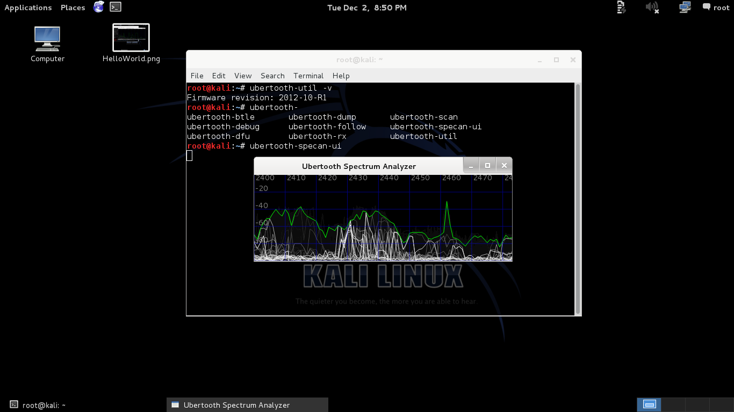

ubertooth-util -v
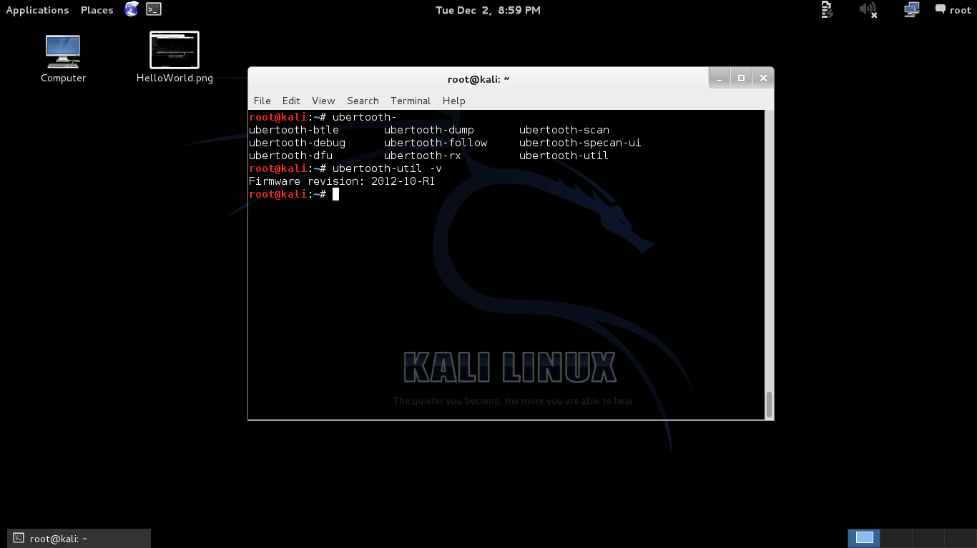
ubertooth-follow //these two require

ubertooth-scan //clock_debug=true outlined above, maybe not

Testing
    - Check Firmware Version w/ $ ubertooth-util -v
    - Cleanup Scripts in each file

Task One: Monitor Airwaves
    - ubertooth-specan-ui
    - ubertooth-rx
    - ubertooth-follow

    - ubertooth-scan
    - kismet with ubertooth plugin
Establish Connection To Ubertooth
intf: ubertooth
name: ubertooth
//Errors start here

Appendix A: File Structure
